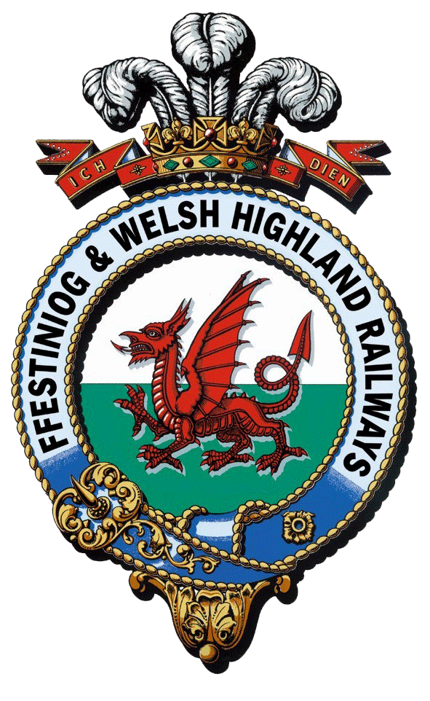
Rheilffyrdd Ffestiniog ac Eryri
Ffestiniog & Welsh Highland Railways

Interpretation and Boston Lodge Project

Equality and Diversity Monitoring Form
The Festiniog Railway Company is committed to providing equal opportunities to all. To help us implement and monitor this policy, all applicants are asked to provide the following information. Any information given will be treated in the strictest of confidence. The information given will be used for the purpose of monitoring and for assisting us in improving our recruitment procedures only.
This form will be separated from the application form immediately on receipt before any consideration of applicants occurs.

- Name of applicant

- Gender
Male
Female
Prefer not to say

- Current Age
16-20
21-30
31-40
41-50
51-60
Over 60
Prefer not to say

- Marital Status
Single
Married
Civil Partner
Divorced
Living as partners
Widowed
Prefer not to say
Other – please specify

- What is your ethnic group?
Choose on option that best describes your ethnic group or background

White
Welsh
English
Scottish
Northern Irish
British
Any other White background, please describe

Mixed/Multiple ethnic groups
White and Black Caribbean
White and Black African
White and Asian
Any other Mixed / Multiple ethnic background, please describe

Asian / Asian British
Indian
Pakistani
Bangladeshi
Chinese
Any other Asian background, please describe

Black / African / Caribbean/ Black British
African
Caribbean
Black British
Any other Black / African / Caribbean/ Black British background, please describe

Prefer not to say

- Do you consider yourself to have a disability?

Yes
No
Prefer not to say

If yes, please give brief details if you wish to do so

- What is your current employment status?

Employed
Self employed
Unemployed
Retired
Student
Other (please state)
Prefer not to say

- What hours do you currently work?
Full-time (at least 30 hours a week)
Part-time (less than 30 hours a week)
Casual/Zero hours
Other (please state)
Prefer not to say

- Is your employment?
Permanent
Fixed Term
Seasonal
Prefer not to say

