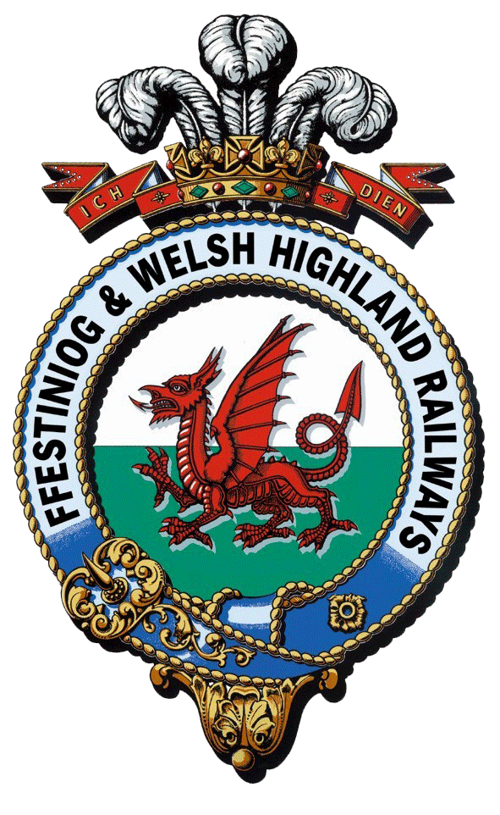
Rheilffyrdd Ffestiniog ac Eryri
Ffestiniog & Welsh Highland Railways
Interpretation and Boston Lodge Project

NLHF Job Application Form
Use this form to apply for any advertised vacancies within the Interpretation and Boston Lodge Project at the Ffestiniog and Welsh Highland Railways. If you wish to apply for multiple roles please submit an application for each role. Please note, if you have come through to our website directly from Indeed, Find a Job or Linkedin we are not able to access your CV on these websites and you will need to email it to us at nlhfapplication@ffwhr.com.
Before you complete this Application Form please ensure you have read and understood the Company's Privacy Notice for Applicants.

The boxes will expand to take as much text as you think is needed.

Position applying for

SECTION 1 | About you
1.Title

2. Forenames
3. Surname
4. Mobile Telephone Number | If you do not have a mobile telephone number please give your main contact number
5. Home Telephone Number
6. Email address
7. Home address
8. Town
9. County
10. Postcode
11. National Insurance Number

SECTION 2 | Employment & Education History
You may refer to your CV for this section provided you are sending it as well as the application form.
12.Previous employment history
For each position please include the name of the employer, the position you held, the date you were appointed, the date you left and a brief description of your duties.

13.Education History
Please include details of all educational establishments attended from secondary school upwards. Please include subjects studied and level / grade achieved.

14. Other relevant qualifications
Please include details of other relevant professional qualifications / training / memberships

SECTION 3 | Why you are suitable for this post
15.Approximately how many years relevant experience do you have for this role?

16.Relevant experience and abilities. Tell us why you are applying for this job and why you think you are a good candidate for the position. The answer to this question plays a critical part in the selection process, take care to ensure you provide evidence of relevant experience, knowledge and skills.

SECTION 4 | General information
17. What is your level of spoken Welsh |  | First language Welsh
 |  | Fluent
 |  | Limited
 |  | Learner
 |  | No Welsh
18. What is your level of written Welsh? |  | I am very confident writing in Welsh
 |  | I can write in Welsh for most situations
 |  | I can write simple sentences in Welsh
 |  | I am a learner
 |  | I cannot write in Welsh
The railway is across multiple sites and whilst posts are usually based in one place there can sometimes be a need to travel between sites which is why we ask about access to a car and driving licence.
19. Do you have access to a private vehicle for the purposes of travelling to and from work
20. Do you hold a full, current driving licence
21. Please give details of any endorsements (or state none)
22. Where did you hear about this vacancy.  Please select all that apply |  | Word of mouth
 |  | Email
 |  | FFWHR project website
 |  | Indeed
 |  | Find a job
 |  | Facebook
 |  | LinkedIn
 |  | Twitter
 |  | Advert
 |  | Other website
23. Do you currently have any links to the Ffestiniog and Welsh Highland Railways? Please give details

24. Have you worked for FFWHR before? Please give details of when and in what capacity.

25. Hobbies and interests.
Tell us a bit more about you, what you like to do outside of work.

SECTION 5 References
We will ask you for details of two referees (one of whom should be your present / most recent employer, or, if a student, your educational establishment; and not relatives should you attend an interview and / or be successful in your application for employment. Please do not provide these details now, we will ask you for details nearer the time and contact will only be made with your authority.

SECTION 6 Interviews
Are there any special requirements that we can assist with to enable you to attend an interview? Details can be entered here or sent by separate email.

SECTION 7 Declaration
Declaration by Applicant: I declare that the information given in this form and in any accompanying documentation is true and complete to the best of my knowledge and belief and give my permission for enquiries to be made to confirm qualifications, experience, dates of employment, right to work in the UK and for the release by other people or organisations of necessary information to verify the content. I understand my application may be rejected and/or I may be subject to summary termination following appointment if I have given any false or misleading information or have withheld any relevant details.
I understand that at the relevant time the Company may ask me to provide the details of two referees (one of whom should be my present / most recent employer or educational establishment, and not relatives) and when requested I will be able to do so.
I have received the Company's Privacy Notice for Applicants, and I confirm that I have read and understood its contents.
I confirm I have the right to live and work in the UK.

I have completed the Equality and Diversity Form and will submit it along with my application form.
I understand that it may be necessary for the Festiniog Railway Company to process information about me under the ‘Special Categories’ of data which are regarded as sensitive personal information. I hereby consent to the processing of such data for the purposes of my application and any subsequent employment with the Company.

Signature of applicant:

Date of application

