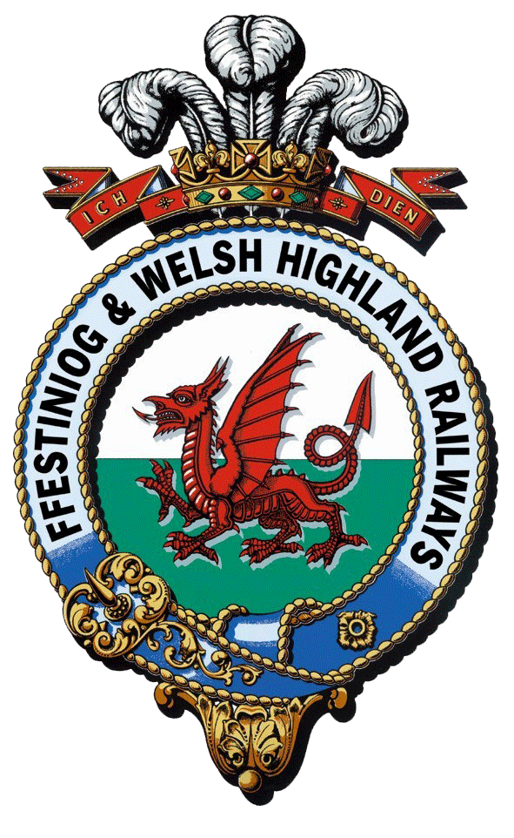
Rheilffyrdd Ffestiniog ac Eryri
Ffestiniog & Welsh Highland Railways
Interpretation and Boston Lodge Project

NLHF Trainee Application Form 2022
Use this form to apply for the following traineeships:
Project Management Trainee
Works Administration Trainee
Interpretation Trainee
If you are interested in more than one post you only need to complete one application form but make sure that in section 3 you talk about each post you are applying for.

Please return the completed form to nlhfapplications@ffwhr.com
The closing date for applications for all traineeships is Friday 27th May 5pm
Interviews are expected to be held on site at the end of June, dates will be published on the website once they have been finalised.
Before you complete this Application Form please ensure you have read and understood the Company's Privacy Notice for Applicants which can be found here:

English:
https://www.festrail.co.uk/wp-content/uploads/2021/03/Privacy-Notice-Applicants.pdf.
Cymraeg:
https://www.festrail.co.uk/wp-content/uploads/2021/03/Hysbysiad-Preifatewydd-I-Ymgeiswyr.pdf

Whilst we would welcome applications from anyone with the right to live and work in the UK we are keen to promote the use of the Welsh language within the workplace, and the development of heritage skills within Wales therefore we particularly encourage applications from those who speak or are learning the language as well as those who come from Wales and / or trained in Wales and are looking for opportunities to use and develop their skills within the heritage sector in Wales.

The boxes will expand as you type in your text. There is no word limit but please try to include as much relevant information as possible in support of your chosen traineeship.

Traineeship(s) applying for
Project Management Trainee

Interpretation Trainee

Works Administration Trainee

SECTION 1 | About you
1.Title

2. Forenames
3. Surname
4. Mobile Telephone Number | If you do not have a mobile phone number please give your main contact number
5. Home Telephone Number
6. Email address
7. Home address (including postcode)
8. Student address (including postcode) – if applicable
9. National Insurance Number

SECTION 2 | Employment & Education History
10.Education History
Please include details of all educational establishments attended from secondary school upwards. Please include subjects studied and level / grade achieved/expected

11. Current employment status - Please mark all that apply

Student full-time

Student part-time

Unemployed/job seeker

Employed full-time

Employed part-time

12.Previous employment history
If you are in employment or have been in the past, for each position please include the name of the employer, the position you held, the date you were appointed, the date you left and a brief description of your duties.

SECTION 3 | Why you are suitable for this traineeship
13.Relevant experience, skills and interest. Tell us why you are interested in a particular traineeship, what specific skills you will bring that you think are relevant and what you want to gain from the experience in terms of your career development.

14. What would you like to be doing in 5-10 years’ time?

SECTION 4 | General information
15. What is your level of spoken Welsh |  | First language Welsh
 |  | Fluent
 |  | Limited
 |  | Learner
 |  | No Welsh
16. What is your level of written Welsh? |  | I am very confident writing in Welsh
 |  | I can write in Welsh for most situations
 |  | I can write simple sentences in Welsh
 |  | I am a learner
 |  | I cannot write in Welsh
The railway is across multiple sites and whilst posts are usually based in one place there can sometimes be a need to travel between sites which is why we ask about access to a car and driving licence.
17. Do you have access to a private vehicle for the purposes of travelling to and from work?
18. Do you hold a full, current driving licence?
19. Please give details of any endorsements (or state none)
21. Where did you hear about this vacancy?

22. Do you have any links to the Ffestiniog and Welsh Highland Railways or have you volunteered or worked for us before? Please give details

23. Hobbies and interests.
Tell us a bit more about you and what you like to do outside of work.

SECTION 5 References
Please provide details of an educational referee at this stage, this should be your most recent educational establishment even if you are now working.

If you are offered a traineeship we will also want to take up your current employment reference if you have one or a personal reference if you are not in employment, but we will ask for those details if we need them.

Educational Referee

SECTION 6 Interviews
Are there any special requirements that we can assist with to enable you to attend an interview? Details can be entered here or sent by separate email.

SECTION 7 Declaration
Declaration by Applicant: I declare that the information given in this form and in any accompanying documentation is true and complete to the best of my knowledge and belief and give my permission for enquiries to be made to confirm qualifications, experience, dates of employment, right to work in the UK and for the release by other people or organisations of necessary information to verify the content. I understand my application may be rejected and/or I may be subject to summary termination following appointment if I have given any false or misleading information or have withheld any relevant details.
I understand that at the relevant time the Company may ask me to provide the details of two referees (one of whom should be my present / most recent employer or educational establishment, and not relatives) and when requested I will be able to do so.
I have received the Company's Privacy Notice for Applicants, and I confirm that I have read and understood its contents.
I understand that it may be necessary for the Festiniog Railway Company to process information about me under the ‘Special Categories’ of data which are regarded as sensitive personal information. I hereby consent to the processing of such data for the purposes of my application and any subsequent employment with the Company.

I confirm I have the right to live and work in the UK.

I have completed the Equality and Diversity Form and will submit it along with my application form.

Signature of applicant:

Date of application

