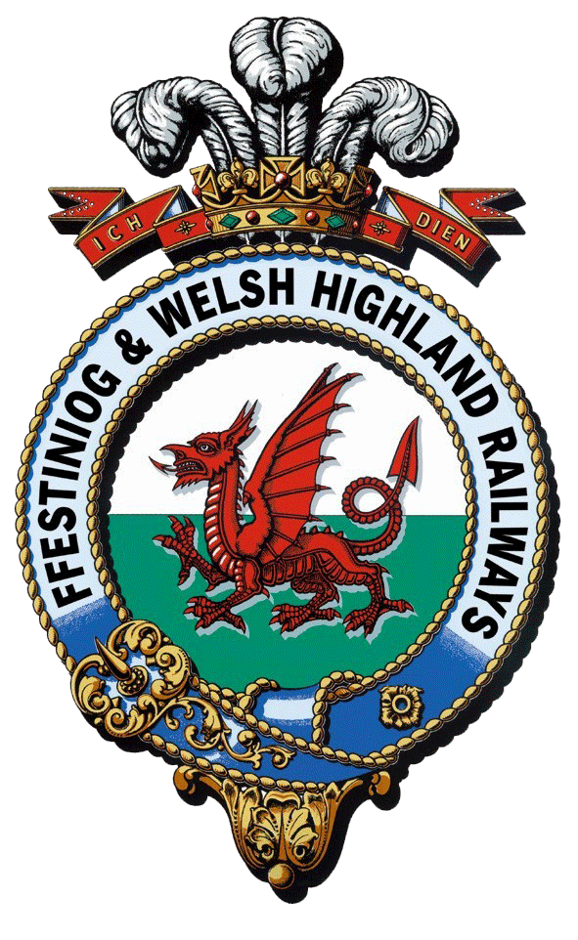
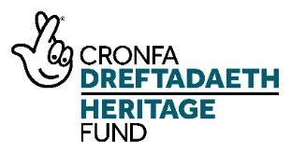
Interpretation and Boston Lodge Works Project

Works Administration Management trainee
Training Plan
 | Question/Task | Response/Description
1 | Name and description of Trainee Position | Works Administration Management trainee  The trainee in this position will work with the Works Administrator and the Engineering Volunteers Leader to process orders for materials and equipment, and undertake engineering volunteer administration including database management. They will receive professional mentoring from within the FfWHR organisation. The trainee will be supported through a programme of training and development, including appropriate qualifications.
2 | Training Manager | - Day to day management by Works Administrator  - Work Placement Officer – Oversee Training Programme (including regular meetings, mentoring and shadowing opportunities) for all traineeships and provide pastoral support  - Mentor – to provide professional insight and identify opportunities for further development according to interest
3 | Specific skills to be taught | - All areas of FfWHR works operations  - General Administration for Boston Lodge staff  - Timesheets (recording hours against external capital projects, staff and volunteers)  - Procurement  - Ordering equipment for works staff/ raising invoices  - Databases  - Monitoring energy use and helping track developing sustainability
4 | Induction content (eg Health and Safety, specific challenges and requirements of working safely on or alongside a working railway line, history of the railways, customer service skills development and training etc) | - Health and Safety at Work  - Purpose of this traineeship  - Formal company induction - Who are we? The hierarchy of the vast FfWHR family  - FfWHR Values & Behaviours  - Specific challenges and requirements of working safely on or alongside a working railway line  - History of the WHR and FfWHR railways  - Background to the NLHF Interpretation and Boston Lodge Project  - FFWHR IT systems
5 | Qualification to be gained by trainee | Potentially City & Guilds Level 2/3 Diploma in Business Administration
6 | Details of any external training required for trainee (eg day a week at college) | 1 Year Student membership of a professional organization/institute
7 | Who will deliver the training internally? | - Works Administrator - Day-to-day  - Work Placement Officer to oversee training programme and offer pastoral care  - General Managers Office Manager (FfWHR) - professional mentoring to encourage areas of interest and identify training and development opportunities
8 | Existing qualifications/accreditation of trainers | Extensive operational experience of FfWHR.
9 | Any further ‘Training the trainer’ required? | No
10 | Placement with another heritage organsiation | Minimum of 1 x week with a placement partner – to be identified according to the development needs of the trainee
11 | Placement in other heritage/cultural/environmental organisations? | To be arranged by Infrastructure Manager or linked to other projects FfWHR consultants may have links to.
 |  | RECRUITING CANDIDATES
12 | What personality type might this course appeal to? Aptitudes/passions/interests | People who might be interested in applying:  - Staff at FfWHR with an interest in developing administrative skills in an engineering environment  - Young people in Gwynedd looking to develop skills  - Existing apprenticeship / trainee programme participants at Grŵp Llandrillo Menai / North Wales Training
13 | What are the minimum qualifications/skills required for trainee | The suitable candidate must have:  - A-levels or equivalent vocational qualifications or a recent graduate  - Attention to detail and good organization  - Good IT skills (desirable)  - Good communication skills (written and oral)  - Interest in working in an engineering environment
14 | Where to recruit candidates? | - Advertise locally via social media  - Grwp Llandrillo Menai / other local colleges  - Online via Facebook and Twitter/ company website  - Careers Wales  - Indeed and findajob
15 | What specific equipment, materials and safety clothing will be required? Estimate of cost per trainee per year | Uniform & safety clothing  - Safety boots  - High vis vest  - FfWHR branded shell and waterproof jackets  IT  - Laptop/computer
 |  | HELP WITH ONWARD EMPLOYMENT OR TRAINING
16 | What career paths/training opportunities are available once the course comes to an end? | All trainees will be offered the following as part of their training programme in order to ensure they are ‘work-ready’:  - Shadowing other FfWHR staff members (including other traineeships) to find out about other areas of work  - Guidance re CV writing  - Interviewing skills workshop  - References provided by relevant manager/s  - Qualification/Certificates  - Possible ongoing administrative role within FfWHR  - Work experience and working alongside other heritage organisations etc. to network and build contacts for the future is included in the training  - Opportunities to take a lead role at volunteer events and guide, model skills and impart knowledge  - Working alongside and training new and less experienced volunteers
17 | How could FFWHR help trainees find further employment and training opportunities after the course ends? | References  Personal recommendations  Networking opportunities and introductions.  Job fairs and associated seminars and events:  - Museums  - Heritage sites  - CADW - Wales  - English Heritage  - National Trust  - Country Parks  - Heritage Railway museums /organisations
18 | What would be the best method for each trainee to record and demonstrate their experience for future employers/further training? | CPD log – to be undertaken at the start of the traineeship what do you know now, what do you need to know, what would you like to develop further, and for this to be reflected on and shared at the end, assisted by:  - Weekly written and photographic progress reports  - Record of all training undertaken (written, photographic, certificates etc.)  - Record of all shadowing instances within the organisation and things learnt  - Record of all placements undertaken  - Record of all mentor-related activity  - Certificates and exam information to evidence achievement – external training/accreditations

