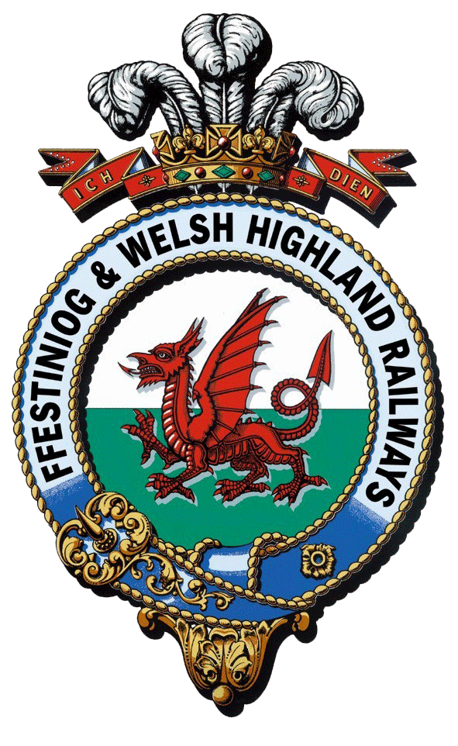
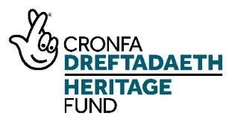
Interpretation and Boston Lodge Works Project

Project Management trainee
Training Plan

 | Question/Task | Response/Description
1 | Name and description of Trainee Position | Project Management (for Heritage Restoration Projects) trainee  The trainee will work with the Heritage Project Manager to support the delivery phase of the project. The work will include the administration, data collection and reporting for the project. The trainee will have the opportunity to develop skills specific to managing heritage projects as the project works through the delivery phase. They will receive professional mentoring from within the FfWHR organisation. The trainee will also be supported through a programme of training and development (including appropriate qualifications).
2 | Training Manager | - NLHF Project Manager – Day-to-Day  - Work Placement Officer – Oversees Training Programme (including regular meetings, mentoring and shadowing opportunities) for all traineeships and provides pastoral support  - Mentor – Provides professional insight and helps trainee to identify opportunities for further development according to interest
3 | Specific skills to be taught | - Heritage Project Management  - Administration of Heritage Project  - Project development (business case, outputs, outcomes,  - Project planning (gantt, critical path, resources)  - Project team roles and professional team  - Stakeholder management & communications  - Cost management  - Procurement  - Change management  - Quality management  - Risk and issue management  - Evaluating Heritage Projects  - Understanding NLHF project systems and submitting NLHF reports
4 | Induction content (eg Health and Safety, specific challenges and requirements of working safely on or alongside a working railway line, history of the railways, customer service skills development and training etc) | - Health and Safety at Work  - Purpose of this traineeship  - Formal company induction - Who are we? The hierarchy of the vast FfWHR family  - FfWHR Values & Behaviours  - Specific challenges and requirements of working safely on or alongside a working railway line  - History of the WHR and FfWHR railways  - Background to the NLHF Interpretation and Boston Lodge Project  - FFWHR IT systems
5 | Qualification to be gained by trainee | Year 1: Open University intro to PM or APM PFQ  Year 2: APM Project Management Qualification delivered via online training
6 | Details of any external training required for trainee (eg day a week at college) | 2-Year student membership of Association for Project Management
7 | Who will deliver the training internally? | - Heritage Project Manager - Day-to-day  - Work Placement Officer - Training programme and pastoral care  - Infrastructure Manager (FfWHR) - professional mentoring to encourage areas of interest and identify training and development opportunities
8 | Existing qualifications / accreditation of trainers | Heritage Project Manager: Managed 3 major NLHF Projects through development and delivery before this one. Experienced trainer/lecturer.
9 | Any further ‘Training the trainer’ required? | No
10 | Placement with another heritage organisation | Minimum of 1 x week with a placement partner – to be identified according to the development needs of the trainee
11 | Placement in other heritage/ cultural/ environmental organisations? | To be arranged by Heritage Project Manager or linked to other projects FfWHR consultants may have links to e.g. National organisation with local heritage sites e.g; National Trust
 |  | RECRUITING CANDIDATES
12 | What personality type might this course appeal to? Aptitudes/passions/interests | A strategic and creative and adaptable individual with excellent interpersonal skills.  People who might be interested in applying:  - Staff or volunteers at FfWHR with an interest in developing project management career  - Welsh students about to graduate wanting to work in heritage and who want to stay in Wales.  - Existing apprenticeship / trainee programme participants at Grŵp Llandrillo Menai / North Wales Training  - Genuine interest in heritage project management  - Someone with existing management / conservation site management / construction site management NVQ
13 | What are the minimum qualifications/skills required for trainee | Degree-level education (or equivalent) preferred. The suitable candidate must have:  - Strong organizational skills  - Ability to plan effectively  - Ability to handle changing situations  - Good IT Skills in Word, Excel (essential) and MS-Project (desirable)  - Good communication skills (written and oral). Effective written & spoken communication skills are key to this role
14 | Where to recruit candidates? | - Universities  - University of Leicester Museum Jobs Desk  - Grwp Llandrillo Menai / other local colleges (for those doing higher level qualifications)  - Careers Wales  - Indeed and findajob  - Local social media
15 | What specific equipment, materials and safety clothing will be required? Estimate of cost per trainee per year | Uniform & safety clothing  - Safety boots  - High vis vest  - FfWHR branded shell and waterproof jackets  IT  - Laptop/computer with specialist MS Project software license (provided by FfWHR)  - Digital Camera
 |  | HELP WITH ONWARD EMPLOYMENT OR TRAINING
16 | What career paths/training opportunities are available once the course comes to an end? | All trainees will be offered the following as part of their training programme in order to ensure they are ‘work-ready’:  - Shadowing other FfWHR staff members (including other traineeships) to find out about other areas of work  - Guidance re CV writing  - Interviewing skills workshop  - References provided by relevant manager/s  - Qualification / Certificates  - Possible ongoing project management role within FfWHR  - Work experience and working alongside other heritage organisations etc. to network and build contacts for the future is included in the training  - Opportunities to take a lead role at volunteer events and guide, model skills and impart knowledge  - Working alongside and training new and less experienced volunteers  - Project Management for organisations across the sector  - NLHF contract work  - Engineering projects  - Construction  - Marketing  - Conservation project management
17 | How could FFWHR help trainees find further employment and training opportunities after the course ends? | References  Personal recommendations  Networking opportunities and introductions.  Job fairs and associated seminars and events:  - Museums  - Heritage sites  - CADW - Wales  - English Heritage  - National Trust  - Country Parks  - Heritage Railway museums / organisations
18 | What would be the best method for each trainee to record and demonstrate their experience for future employers/further training? | CPD log to be undertaken at the start of the traineeship: what do you know now; what do you need to know; what would you like to develop further? This to be reflected on and shared at the end, assisted by:  - Weekly written and photographic progress reports  - Record of all training undertaken (written, photographic, certificates etc.)  - Record of all shadowing instances within the organisation and things learnt  - Record of all placements/visits to other projects undertaken  - Record of all mentor-related activity  - Certificates and exam information to evidence achievement – external training/accreditations

