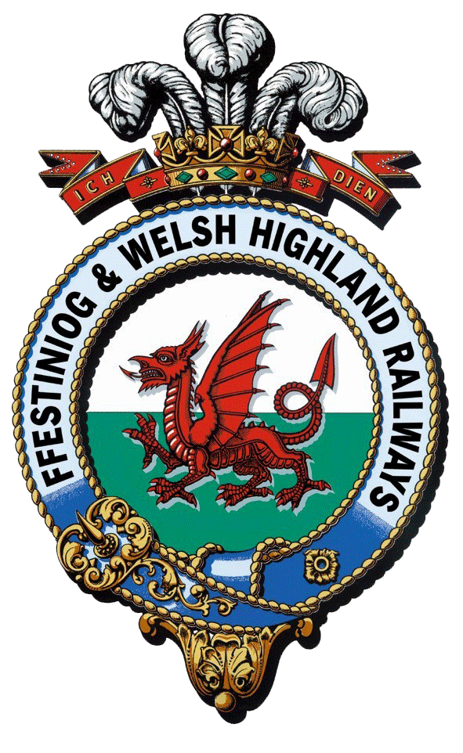
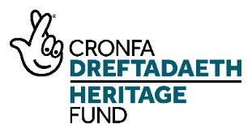
Interpretation and Boston Lodge Works Project

Interpretation trainee
Training Plan

 | Question/Task | Response/Description
1 | Name and description of Trainee Position | Interpretation trainee  The trainee in this position will work with the Interpretation Officer to support delivery of the NLHF project. They will coordinate volunteers, including volunteer administration and database management, working with them to develop and collate interpretation content for the railway and for Boston Lodge Works. They will receive professional mentoring from the Interpretation Consultant. The trainee will be supported through a programme of training and development (including appropriate qualifications).
2 | Training Manager | - Interpretation Officer/Visitor Experience Manager – Day-to-Day  - Work Placement Officer – Oversee Training Programme (including regular meetings, mentoring and shadowing opportunities) for all traineeships and provide pastoral support  - Mentor – to provide professional insight and identify opportunities for further development according to interest
3 | Specific skills to be taught | - All areas of heritage interpretation and strategic communication  - Heritage research  - Content development and creation (including Interpretive Writing, writing and implementing an Interpretation Plan, and Interpretive Themes)  - Storytelling  - Bilingual Interpretation  - Exhibition design  - All areas of interpretation management, including events, tours and hands-on engagement activities  - Basic time and project management  - How to coordinate and manage a team of volunteers  - Digital marketing (what goes on website, why, for how long)  - Archiving – traditional and digital  - Training teams of people – Customer service and tour guiding
4 | Induction content (eg Health and Safety, specific challenges and requirements of working safely on or alongside a working railway line, history of the railways, customer service skills development and training etc) | - Health and Safety at Work  - Purpose of this traineeship  - Formal company induction - Who are we? The hierarchy of the vast FfWHR family  - FfWHR Values & Behaviours  - History of the WHR and FfWHR railways, slate industry and the UNESCO bid  - Background to the NLHF Interpretation and Boston Lodge Project  - FFWHR IT systems  - Visitor Experience Customer Service training
5 | Qualification to be gained by trainee | Year 1 - GEM Heritage Interpretation, Welsh Level 2, Digital Preservation Management (People’s Collection Wales)  Year 2 - Tour Guide/ Storytelling training - Tour Guiding - Level 2 (OCN NI)
6 | Details of any external training required for trainee (eg day a week at college) | 2 Year Student membership of AHI
7 | Who will deliver the training internally? | - Interpretation Officer/Visitor Experience Manager - Day-to-day  - Work Placement Officer - Training programme and pastoral care  - Exhibition Designers - professional mentoring to encourage areas of interest and identify training and development opportunities
8 | Existing qualifications/accreditation of trainers | Extensive operational experience of exhibition design.
9 | Any further ‘Training the trainer’ required? | No
10 | Placement with another heritage organisation | Site visits to experience other interpretation within heritage orgs e.g. St Fagins, and minimum of 1 x week with a placement partner – to be identified according to the development needs of the trainee  May include partners such as:  - National Slate Museum (links to World Heritage bid family)  - Cadw  - National Trust (Penrhyn Castle and Plas Newydd)  - Maritime museum  - Llechwedd
11 | Placement in other heritage/cultural/environmental organisations? | To be arranged by the Interpretation Officer or linked to other projects FfWHR consultants may have links to e.g. national organisation with local heritage sites e.g; National Trust, CADW, Chatsworth / Tower of London / Big Pit – places with tours, Beamish, St Fagan’s, National Slate Museum, Llechwedd, Severn Valley Railway & Engine House, National Railway Museum York, or other science museum.
 |  | RECRUITING CANDIDATES
12 | What personality type might this course appeal to? Aptitudes/passions/interests | People who might be interested in applying:  - Staff at FfWHR with an interest in developing interpretation career  - Young people in Gwynedd looking to develop skills  - Existing apprenticeship / trainee programme participants at Grŵp Llandrillo Menai / North Wales Training  - Someone with existing heritage/design/communications qualification  - New graduates in a related discipline
13 | What are the minimum qualifications/skills required for trainee | Degree-level education (or equivalent) preferred. The suitable candidate must have:  - Strong organizational skills  - Ability to plan and research effectively and independently  - Ability to handle changing situations  - Good IT Skills in Word, Excel (essential) and design software (desirable)  - Good communication skills (written and oral). Effective written & spoken communication skills are key to this role  - Welsh language (desirable)  - Outgoing personality  - Genuine interest in heritage interpretation
14 | Where to recruit candidates? | - Universities – via jobs fairs, Aberystwyth and Bangor University onward employment team via existing contacts  - University of Leicester Jobs desk  - Grwp Llandrillo Menai / other local colleges  - Careers Wales  - GEM  - Indeed and findajob  - Local social media
15 | What specific equipment, materials and safety clothing will be required? Estimate of cost per trainee per year | IT  - Laptop/computer with specialist software license e.g. Adobe Creative Suite  - Digital Camera  Uniform & safety clothing  - Safety boots  - High vis vest  - FfWHR branded shell and waterproof jackets
 |  | HELP WITH ONWARD EMPLOYMENT OR TRAINING
16 | What career paths/training opportunities are available once the course comes to an end? | All trainees will be offered the following as part of their training programme in order to ensure they are ‘work-ready’:  - Shadowing other FfWHR staff members (including other traineeships) to find out about other areas of work  - Guidance re CV writing  - Interviewing skills workshop  - References provided by relevant manager/s  - Qualification/Certificates  - Possible ongoing interpretation/ visitor experience role within FfWHR  - Work experience and working alongside other heritage organisations etc.  - Opportunities to take a lead role at volunteer events and guide, model skills and impart knowledge  - Working alongside and training new and less experienced volunteers  - Marketing  What roles the training might lead into:  - Freelance interpretation consultant  - Museum/heritage work with CADW, National Trust  - Work with interpretation organisations  - Marketing and Customer Services  - Interpretation Officer  - Volunteer interpretation assistant  - Heritage research roles  - Onward studies to degree/MA level
17 | How could FFWHR help trainees find further employment and training opportunities after the course ends? | References  Personal recommendations  Networking opportunities and introductions.  Job fairs and associated seminars and events:  - Museums  - Heritage sites  - CADW - Wales  - English Heritage  - National Trust  - Country Parks  - Heritage Railway museums /organisations
18 | What would be the best method for each trainee to record and demonstrate their experience for future employers/further training? | CPD log – to be undertaken at the start of the traineeship what do you know now, what do you need to know, what would you like to develop further, and for this to be reflected on and shared at the end, assisted by:  - Weekly written and photographic progress reports  - Record of all training undertaken (written, photographic, certificates etc.)  - Record of all shadowing instances within the organisation and things learnt  - Record of all placements undertaken  - Record of all mentor-related activity  - Certificates and exam information to evidence achievement – external training/accreditations

