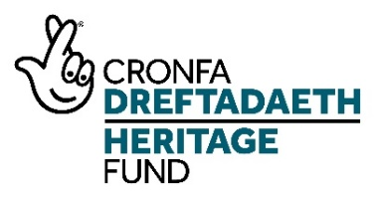
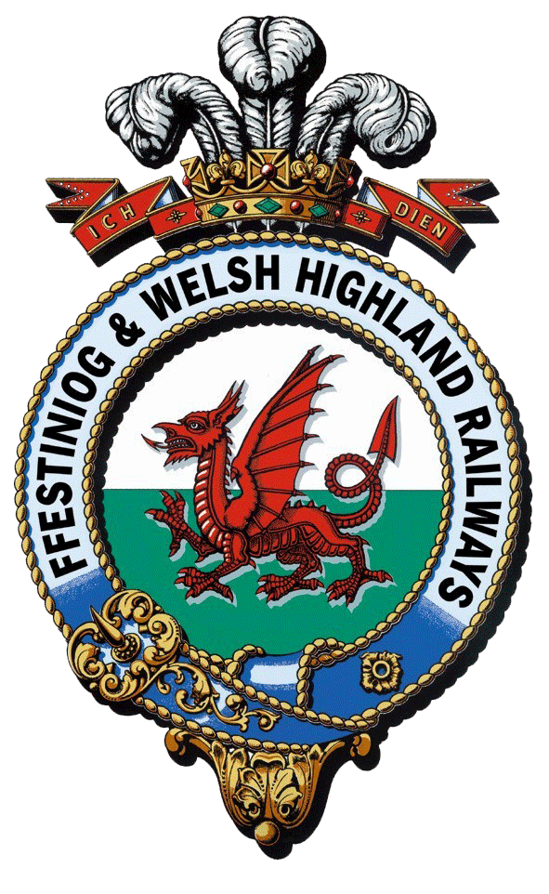
Rheilffyrdd Ffestiniog ac Eryri
Ffestiniog & Welsh Highland Railways
Interpretation and Boston Lodge Project

Engineering Volunteers Leader – Application Pack

Please make sure you read through this document and the Activity Plan carefully before you apply.

Project Information

An overview of the project can be found on the project website

https://nlhfproject.festrail.co.uk/project-overview/

Please do read through this carefully as the post is one of several funded by the project and understanding the whole project is essential.

It is also well worth watching the short project introduction video that can be found here:

https://nlhfproject.festrail.co.uk/video/

Staffing

To deliver this ambitious program will be the Heritage Project Manager along with an Interpretation Officer, a Training and Events Supervisor, an Engineering Volunteer Supervisor and a Work Placement Officer and a Construction Project Manager. There will also be three trainee posts covering Interpretation, Works Administration and Project Management.

Target audiences
The project has a number of new target audiences including non-traditional railway visitors, people visiting from centres of urban deprivation, local people with family connections, schools in communities along the railway, young people in Gwynedd looking to develop skills, older people at risk of social isolation and adults working or living in stressful environments.
These are in addition to our current audiences of staff, volunteers, family visitors, adults on holiday, tour groups and international visitors, spectators watching the trains and visiting stations, special interest groups, ardent rail enthusiasts and local people attending special events.
See Action Plan Page p32ff

Engineering Volunteers Leader

A key post for the project is the Engineering Volunteers Leader who will resource and facilitate working parties to deliver the NLHF project heritage engineering projects at Boston Lodge Works, and, in the process, manage and facilitate the transfer of skills and knowledge to and between volunteers recruited to the teams working on these projects.

The Engineering Volunteers Leader will be responsible for delivering the following project activities.

3G Engineering volunteer skills and knowledge transfer programme (Activity Plan Page 75)

3I Project support volunteers (jointly with Small Loco Shed team) (Activity Plan Page 78

More details can be found in the Activity Plan that is available to download from the jobs page. Please make sure you understand what is involved. Your application should clearly demonstrate that you have the relevant skills and experience and that you understand what will be needed.

The scope of the post has been extended since it was first advertised to include line management responsibilities and an organisation wide brief for volunteer recruitment and development and is considered to be a post at senior management level.

Job Description All to be re-translated

1. Post Details:

Post Title: Engineering Volunteers Leader
Post Reports to: Heritage Project Manager
Location: Boston Lodge, Penrhyndeudraeth, Gwynedd
Salary: £31,000+ per annum
Hours: Full time
Duration: 3 years

- Purpose of Job:

To enable the FfWHR to deliver heritage engineering projects at Boston Lodge Works as part of the NLHF supported Interpretation and Boston Lodge development project and to lead volunteer recruitment, development and engagement at a strategic level across the organisation. The post holder will be responsible for resourcing and facilitating engineering projects by recruiting and leading volunteer working parties to deliver the project objectives and, in the process; manage and facilitate the transfer of skills and knowledge to and between the volunteers. The post holder will help extend this work to other areas of volunteering in the organisation and so strengthen volunteer recruitment and development generally. This will include the development of clear policies for volunteers and ensuring the HOPs system (https://www.hops.org.uk/) is used to track volunteer involvement, skills and training.

The postholder will manage the Work Placement Officer and the Training Events and Workshop Supervisor.

Dependent on the skills and knowledge of the applicant they may also be asked to advise the Heritage Project Manager in the delivery of the capital works on site with regard to logistics and operational requirements particularly and this would be reflected in the salary.

- Principal Accountabilities:
  - Recruit and lead volunteer teams for the heritage engineering projects and project support activities within the NLHF project. Work closely with the Work Placement Officer to support and guide wider volunteer recruitment.
  - Develop and manage the engineering skills, learning, and knowledge transfer programme to enable transfer of skills among heritage engineering projects’ team members. Use this as a model for mapping skills development for volunteers in all areas and driving the use of HOPs to record this.
  - Manage the arrangement of working parties and projects to meet or exceed the project requirements set out in the Activity Plan.
  - Supervise the volunteers during the working parties and on work placements.
  - Coach others in arranging and leading volunteer working parties whether staff or volunteers and then supervise the working party supervisors.
  - Manage the Training Events and Workshop Supervisor who is responsible for arranging heritage learning courses, develop and maintain workshop plans and materials, arranging staff and volunteers to support and deliver events and workshops, deliver training for volunteer trainers and programme and deliver specialist heritage learning, schools workshops and experiences and public workshops
  - With the Work Placement Officer, develop and manage training plans for heritage engineering project volunteers and work placements
  - Audit skills among the heritage engineering projects’ teams, identify and recruit to fill any skills gaps
  - Manage the health and safety and welfare for all programme participants
  - Liaise with the FfWHR Marketing Department to record activity to promote the NLHF project through marketing and promotional material
  - Support the work of the NLHF project evaluation consultants by providing input into the evaluation of engineering projects specifically and volunteer activities generally.
  - Ensure volunteer teams are in place and provided with appropriate support for the Small Loco Shed
  - Lead work with other project team members to develop volunteers generally in terms of recruitment (including taster days), using HOPS to map experience and skills, ensuring volunteers are allocated to appropriate teams and are managed effectively.
  - Represent volunteers as a member of the senior management team for the railway and be a member of the Project Board.

- Job Context

The Post Holder will report to the Heritage Project Manager. The Post Holder will be based at Boston Lodge Works but may need to work at other FfWHR locations as required.

- Experience, Knowledge, Qualification and Training:

Essential (E) Desirable (D)

Experience
- Significant experience in team leadership in an engineering project environment covering a wide range of projects (E)
- At least 5 years experience of mentoring or training (E)
- At least 5 years experience of working with volunteers particularly in skills development (E)
- At least 5 years experience of managing team leaders (E)
- Experience of working at a senior/strategic level including the development of policies and long term plans (D)
- Experience of delivering National Lottery Heritage Fund grant aided projects (D)

Knowledge
- An understanding of heritage engineering processes and skills (E)
- Knowledge of project planning and implementation (E)
- Knowledge of volunteer recruitment processes and record keeping (E)
- Knowledge of NLHF processes and requirements (D)
- Knowledge of Health and Safety requirements in a workshop (E) and railway setting (D)

Qualifications/Accreditations
- Relevant degree or equivalent
- Member of related professional body

Skills
- Team leadership skills (E)
- Management skills at a strategic level with volunteers (E)
- Practical heritage engineering skills (E)
- Excellent analytical, problem solving and organisational skills (E)
- Highly effective communication skills, both oral and written (E)
- Good report writing skills (E)
- Good IT skills (E)
- Excellent negotiation and persuasive skills (E)
- Team leading skills; able to manage and motivate staff, trainees, volunteers and external consultants (E)
- Clear people-centred focus and excellent relationship management skills (E)
- The ability to speak Welsh is highly desirable (D)
- General financial and budget awareness (D)

(C) Further information about the post

In recognition of the higher level expected for this post it will attract a salary dependant on skills and experience but a minimum of £31,000

The contract is full-time for 3 years, starting in early 2022, based at Boston Lodge, Minffordd, Penrhyndeudraeth.

Weekend working will be required for this position. Candidates must be prepared to be flexible over working times / days to facilitate the volunteer-led working parties.

Railway employees benefit from
- A minimum of 28 days paid holiday, inclusive of all bank and public holidays
- Enrolment into the company pension scheme after a qualifying period
- Company enhanced sick pay
- Travel benefits on the Ff&WHR and on national rail according to the Rail Staff Travel rules in place at the time of employment.

- How to apply

Applications must be submitted via the project website and each application should contain:

A completed application form

A completed equality and diversity monitoring form – this is used only to monitor our recruitment and does not form part of the selection process.

A Curriculum Vitae may also be submitted in support of your application.

If you would like to discuss the project or the role further or arrange a visit to Boston Lodge to see the workshops please contact Edwina Bell on ebell@ffwhr.com

The deadline for completed applications is mid-day 14th February and they should be sent to ebell@ffwhr.com

All valid applications received will be responded to say whether applicants have been short listed or not.

Interviews are expected to take place on 17th February.

