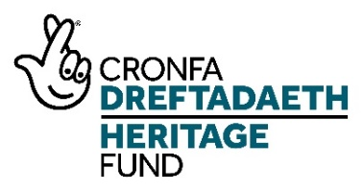
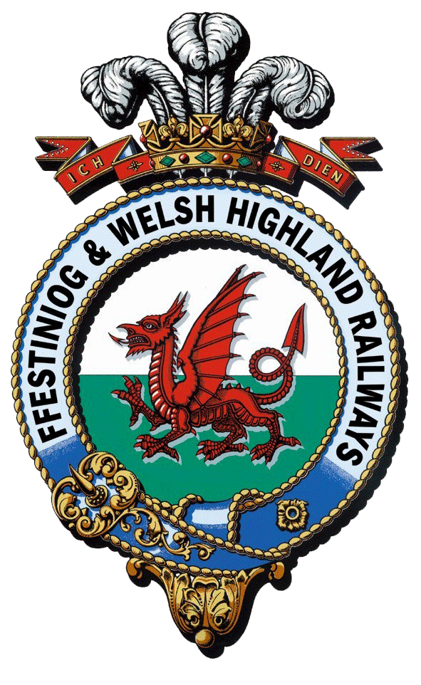
Rheilffyrdd Ffestiniog ac Eryri
Ffestiniog & Welsh Highland Railways
Interpretation and Boston Lodge Project

Interpretation Officer – Application Information

Project Information

An overview of the project can be found on the project website

https://nlhfproject.festrail.co.uk/project-overview/

Please do read through this carefully as the post is one of several funded by the project and understanding the whole project is essential.

It is also well worth watching the short project introduction video that can be found here:

Video – Interpretation and Boston Lodge Project (festrail.co.uk)

Staffing

To deliver this ambitious program will be the Heritage Project Manager along with an Interpretation Officer, a Training and Events Supervisor, an Engineering Volunteer Supervisor and a Work Placement Officer and a Construction Project Manager. There will also be three trainee posts covering Interpretation, Works Administration and Project Management.

Target audiences
The project has a number of new target audiences including non-traditional railway visitors, people visiting from centres of urban deprivation, local people with family connections, schools in communities along the railway, young people in Gwynedd looking to develop skills, older people at risk of social isolation and adults working or living in stressful environments.
These are in addition to our current audiences of staff, volunteers, family visitors, adults on holiday, tour groups and international visitors, spectators watching the trains and visiting stations, special interest groups, ardent rail enthusiasts and local people attending special events.
See Action Plan Page p32ff

Interpretation Officer

The Interpretation Officer is a client-side role for the railway and will help deliver the interpretation strand of the project and is responsible for the following:

3A Developing Interpretation: Researching and digitising archives

3B Developing Interpretation: Tell me a story

3C Developing Interpretation: New interpretation at hubs, mini-hubs and interpretation points

3D Developing Interpretation: Developing the guided tour of Boston Lodge Works

3E: Learning to be a guide

5B: Guided Tours

5D: Explainer training

Please see Activity Plan for more details on each of these

Key duties are to support FfWHR and their Interpretation Consultant to deliver a scheme of new high-quality interpretation and engagement activities, at Boston Lodge Works, Porthmadog, and across the FfWHR (see Interpretation Design). The Officer will also be responsible for developing a new programme of guided tours at Boston Lodge Works

More details can be found in the Activity Plan and the Interpretation Framework that are available to download from the jobs page. Please make sure you understand what is involved. Your application should clearly demonstrate that you have the relevant skills and experience and that you understand what will be needed.

Job Description

Interpretation Officer

Job Description

1. Post Details:

Post Title: Interpretation Officer
Post Reports to: NLHF Project Manager, FfWHR Customer Services Manager
Location: Porthmadog, Gwynedd
Salary: pro rata per annum
Hours: Part-time (0.8 FTE)
Duration: 2.5 years

- Purpose of Job:

To support FfWHR and their Interpretation Consultant to deliver a scheme of new high-quality interpretation and engagement activities, at Boston Lodge Works, Porthmadog, and across the FfWHR. The Officer will also be responsible for developing a new programme of guided tours at Boston Lodge Works. They will ensure that the outputs are delivered on time and to the required standards. They will report to the the FfWHR Customer Services Manager and work closely with the NLHF Heritage Project Manager and the Interpretation Consultants.

- Principal Accountabilities:
  - Supervise the FfWHR Interpretation Trainee
  - Recruit and organise Interpretation Volunteers (Archive Research, Story Collection, Exhibitions, Tour Development, Tour Guides)
  - Develop and manage training plans for interpretation volunteers and work placements. Deliver training where appropriate.
  - Organise interpretation assets – i.e. recordings, images, copy – for ease of use in interpretive media outputs
  - Support volunteer Tour Guides (training will be provided) to deliver guided tours at Boston Lodge Works
  - Develop the Guided Tours programme at Boston Lodge Works
  - Support the Interpretation Consultants to develop and deliver new interpretation at Boston Lodge Works and across FfWHR locations
  - Support the development and delivery of interpretation across the railway and at Boston Lodge Works by working closely with the Interpretation Consultants.
  - Involvement in the Slate Landscapes of North Wales UNESCO project, and networking with the other organisations involved in that
  - Liaise with FfWHR marketing to record activity to support marketing and promotional material
  - Support the work of the NLHF project evaluation consultants by undertaking appropriate evaluation of activities

- Job Context

The Post Holder will report to the FfWHR Customer Services Manager. The Post Holder will assume responsibility for an Interpretation Trainee who will be mentored by the Interpretation Consultant.

- Experience, Knowledge, Qualification and Training:

Essential (E) Desirable (D)

Experience
- Significant experience at coordinating and managing interpretation projects (E)
- Using archives for researching and developing interpretation (E)
- Co-creation with audiences (including local communities) to develop interpretation (E)
- Significant experience of successfully working with and leading internal and external teams (E)
- Experience of training or mentoring (E)
- Experience of monitoring budgets (E)
- Experience of working with volunteers to develop interpretation (E)

- Experience of delivering interpretation projects within capital development projects (D)
- Experience of delivering National Lottery Heritage Fund interpretation projects (D)

Knowledge
- Significant professional and technical knowledge of heritage interpretation and best practice in the field (E)
- Significant knowledge and understanding of audience-appropriate interpretation (E)
- Significant knowledge and understanding of a wide range of interpretive media and delivery mechanisms (E)
- Significant knowledge of interpretive design and contract management (D)
- Knowledge of NLHF processes and requirements (D)

Qualifications/Accreditations
- Relevant degree or equivalent e.g. museum studies, heritage communication, design (D)
- Member of related professional body – e.g. Association for Heritage Interpretation, Museums Association (D)

Skills
- Interpretation Project Management skills (E)
- Team leading skills; able to manage and motivate staff, trainees, volunteers and external consultants (E)
- Excellent analytical, problem solving and organisational skills including managing own time and workload (E)
- Budget management skills (E)
- Highly effective communication skills, both oral and written (E)
- Excellent negotiation and persuasive skills (E)
- Clear skills in relationship building with varied community groups and volunteers (E)
- Mentoring or training skills (E)
- Skills in working with teams of
- Design software (e.g. Adobe Creative Suite) skills (D)
- The ability to speak Welsh (D)

(C) Further information about the post

The attracts a salary of £21,200 per annum which is pro rata of £26,500 for a full time equivalent.

The contract is 0.8FTE and is for 2.5 years, starting in early 2022, and is expected to be based at Harbour Station, Porthmadog although with some time spent at Boston Lodge, Penrhydaedraeth. As this post is part-time it will be possible for the hours to be flexible to suit the right candidate.

Railway employees benefit from
- A minimum of 28 days paid holiday, inclusive of all bank and public holidays. Pro rata for part-time posts.
- Enrolment into the company pension scheme after a qualifying period
- Company enhanced sick pay
- Travel benefits on the Ff&WHR and on national rail according to the Rail Staff Travel rules in place at the time of employment.

- How to apply

Applications must be submitted to nlhfapplications@ffwhr.com via the project website and each application should contain:
A completed application form
A Curriculum Vitae
A completed equality and diversity monitoring form – this is used only to monitor our recruitment and does not form part of the selection process.

A visit to Harbour Station may be possible over the holiday period on a day when trains are running. If you would like to discuss the project or the role further or wish to arrange a visit then please contact Edwina Bell on ebell@ffwhr.com.

The deadline for completed applications is mid-day 10th January 2022.

All valid applications received will be responded to say whether applicants have been short listed or not.

Interviews are expected to take place on 25th January 2021.

