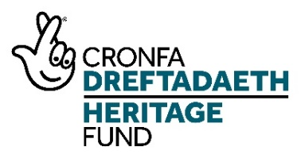
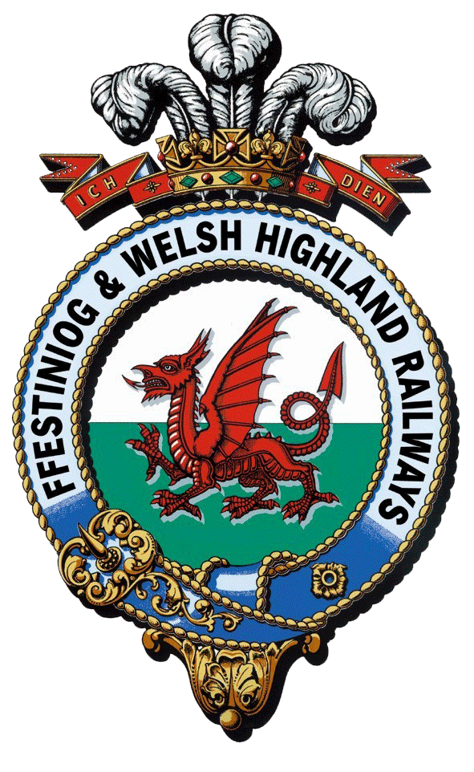
Rheilffyrdd Ffestiniog ac Eryri
Ffestiniog & Welsh Highland Railways
Interpretation and Boston Lodge Project

Work Placement Officer – Application Information

Project Information

An overview of the project can be found on the project website

https://nlhfproject.festrail.co.uk/project-overview/

Please do read through this carefully as the post is one of several funded by the project and understanding the whole project is essential.

It is also well worth watching the short project introduction video that can be found here:

https://nlhfproject.festrail.co.uk/video/

Staffing

To deliver this ambitious program will be the Heritage Project Manager along with an Interpretation Officer, a Training and Events Supervisor, an Engineering Volunteer Supervisor and a Work Placement Officer and a Construction Project Manager. There will also be three trainee posts covering Interpretation, Works Administration and Project Management.

Target audiences
The project has a number of new target audiences including non-traditional railway visitors, people visiting from centres of urban deprivation, local people with family connections, schools in communities along the railway, young people in Gwynedd looking to develop skills, older people at risk of social isolation and adults working or living in stressful environments.
These are in addition to our current audiences of staff, volunteers, family visitors, adults on holiday, tour groups and international visitors, spectators watching the trains and visiting stations, special interest groups, ardent rail enthusiasts and local people attending special events.
See Action Plan Page p32ff

Volunteers
In working with volunteers FfWHR wants to:
- Provide suitable training for volunteers to undertake activities
- Retain specialised heritage skills amongst its work-force
- Recruit volunteers who are willing to learn and adapt
- Adhere to legislation on competencies, safe working
- Have volunteer leaders in some areas to support paid staff
- Recruit more volunteers from the local community
- Diversify its volunteer base
See Action Plan Page 98ff

Work Placement Officer

The Work Placement Officer will help deliver the skills strand of the project and is responsible for the following:

2A Work Placements (Activity Plan Page 64)

2B Work placement outreach (Activity Plan Page 65)

2C Volunteer outreach (Activity Plan Page 66)

Key duties will include supporting three trainees within the project, organising work placements for the project and within the wider organisation, and developing and maintaining training plans. The Officer will also support further consultation about the Activity Plan and undertake volunteer outreach and recruitment, acting as a point of contact for all new volunteers.

More details can be found in the Activity Plan that is available to download from the jobs page. Please make sure you understand what is involved. Your application should clearly demonstrate that you have the relevant skills and experience and that you understand what will be needed.

Job Description

1. Post Details:

Post Title: Work Placement Officer
Post Reports to: Heritage Project Manager
Location: Porthmadog, Gwynedd
Salary: pro rata per annum
Hours: Part time (0.6 FTE) - flexible
Duration: 3 years

- Purpose of Job:

To enable the FfWHR to support all trainees and work placements associated with the NLHF Interpretation and Boston Lodge development project and in the wider organisation, including the initial and continual development of training plans. The Officer will also support further consultation about the Activity Plan and undertake volunteer outreach and recruitment, acting as a point of contact for all new volunteers.

- Principal Accountabilities:
  - Support three trainees employed by FfWHR as part of this NLHF project
  - Administer trainee internal and external qualifications
  - Write and develop bespoke training plans for NLHF trainees
  - Be a point of contact for trainees, work placement applicants and new volunteers for the wider FfWHR organisation
  - Develop and maintain work placement training plans for the NLHF project as detailed in the Activity Plan and for the wider FfWHR organisation, these can be school, college or university level.
  - Support further consultation as proposed in the Activity Plan
  - Deliver outreach to recruit for work placements and volunteers
  - Liaise with the FfWHR Marketing Department to promote the trainees’ contribution to the NLHF project and wider volunteering activity.
  - Support further consultation with Activity Plan target groups.
  - Support the work of the NLHF project evaluation consultants by undertaking appropriate evaluation of activities

- Job Context

The Post Holder will report to the Heritage Project Manager. The Post Holder will be required to liaise with all department volunteer liaisons, volunteer project and team leaders. The post will be based at Harbour Station however the Post Holder will be expected to travel to all locations on the FfWHR as required.

- Experience, Knowledge, Qualification and Training:

Essential (E) Desirable (D)

Experience
- Significant experience as a coordinator of mentoring, training and work placement programmes (E)
- Experience of developing and supporting delivery of training plans (E)
- Experience of recruitment of volunteers & volunteer management (E)
- Significant experience of successfully working with internal and external teams (E)
- Experience of working with volunteers and young people from local communities (E)
- Experience of delivering National Lottery Heritage Fund projects (D)
- Experience of consulting with external community groups and organisations (D)

Knowledge
- Professional knowledge of mentoring, training and work placement programmes (E)
- An understanding of the legalities around the engaging of individuals undertaking training, work placements and volunteering (E)
- Significant knowledge of partnership working to support the delivery of programmes (E)
- Knowledge of NLHF processes and requirements (D)

Qualifications/Accreditations
- Relevant qualification e.g. teaching qualification, volunteer management (D)
- Member of related professional body – e.g. ITOL, AVM (D)

Skills
- Training and workplace management skills (E)
- Volunteer management skills (E)
- Excellent analytical, problem solving and organisational skills (E)
- Highly effective communication skills, both oral and written (E)
- Presentation skills (E)
- Excellent IT skills (E)
- Excellent negotiation and persuasive skills (E)
- Team leading skills; able to manage and motivate trainees, work placements and volunteers (E)
- Budget management (D)
- The ability to speak Welsh (E)

(C) Further information about the post

The attracts a salary of £15,900 per annum which is pro rata of £26,500 for a full time equivalent.

The contract is 0.6FTE and is for 3 years, starting in early 2022, and is expected to be based at Harbour Station, Porthmadog although with some time spent at Boston Lodge, Penrhydaedraeth. As this post is part-time it will be possible for the hours to be flexible to suit the right candidate.

Railway employees benefit from
- A minimum of 28 days paid holiday, inclusive of all bank and public holidays. Pro rata for part-time posts.
- Enrolment into the company pension scheme after a qualifying period
- Company enhanced sick pay
- Travel benefits on the Ff&WHR and on national rail according to the Rail Staff Travel rules in place at the time of employment.

- How to apply

Applications must be submitted to nlhfapplications@ffwhr.com via the project website and each application should contain:
A completed application form
A Curriculum Vitae
A completed equality and diversity monitoring form – this is used only to monitor our recruitment and does not form part of the selection process.

If you would like to discuss the project or the role further please contact Edwina Bell on ebell@ffwhr.com

The deadline for completed applications is mid-day 6th December.

All valid applications received will be responded to say whether applicants have been short listed or not.

Interviews are expected to take place on 20, 21 or 22 December.

